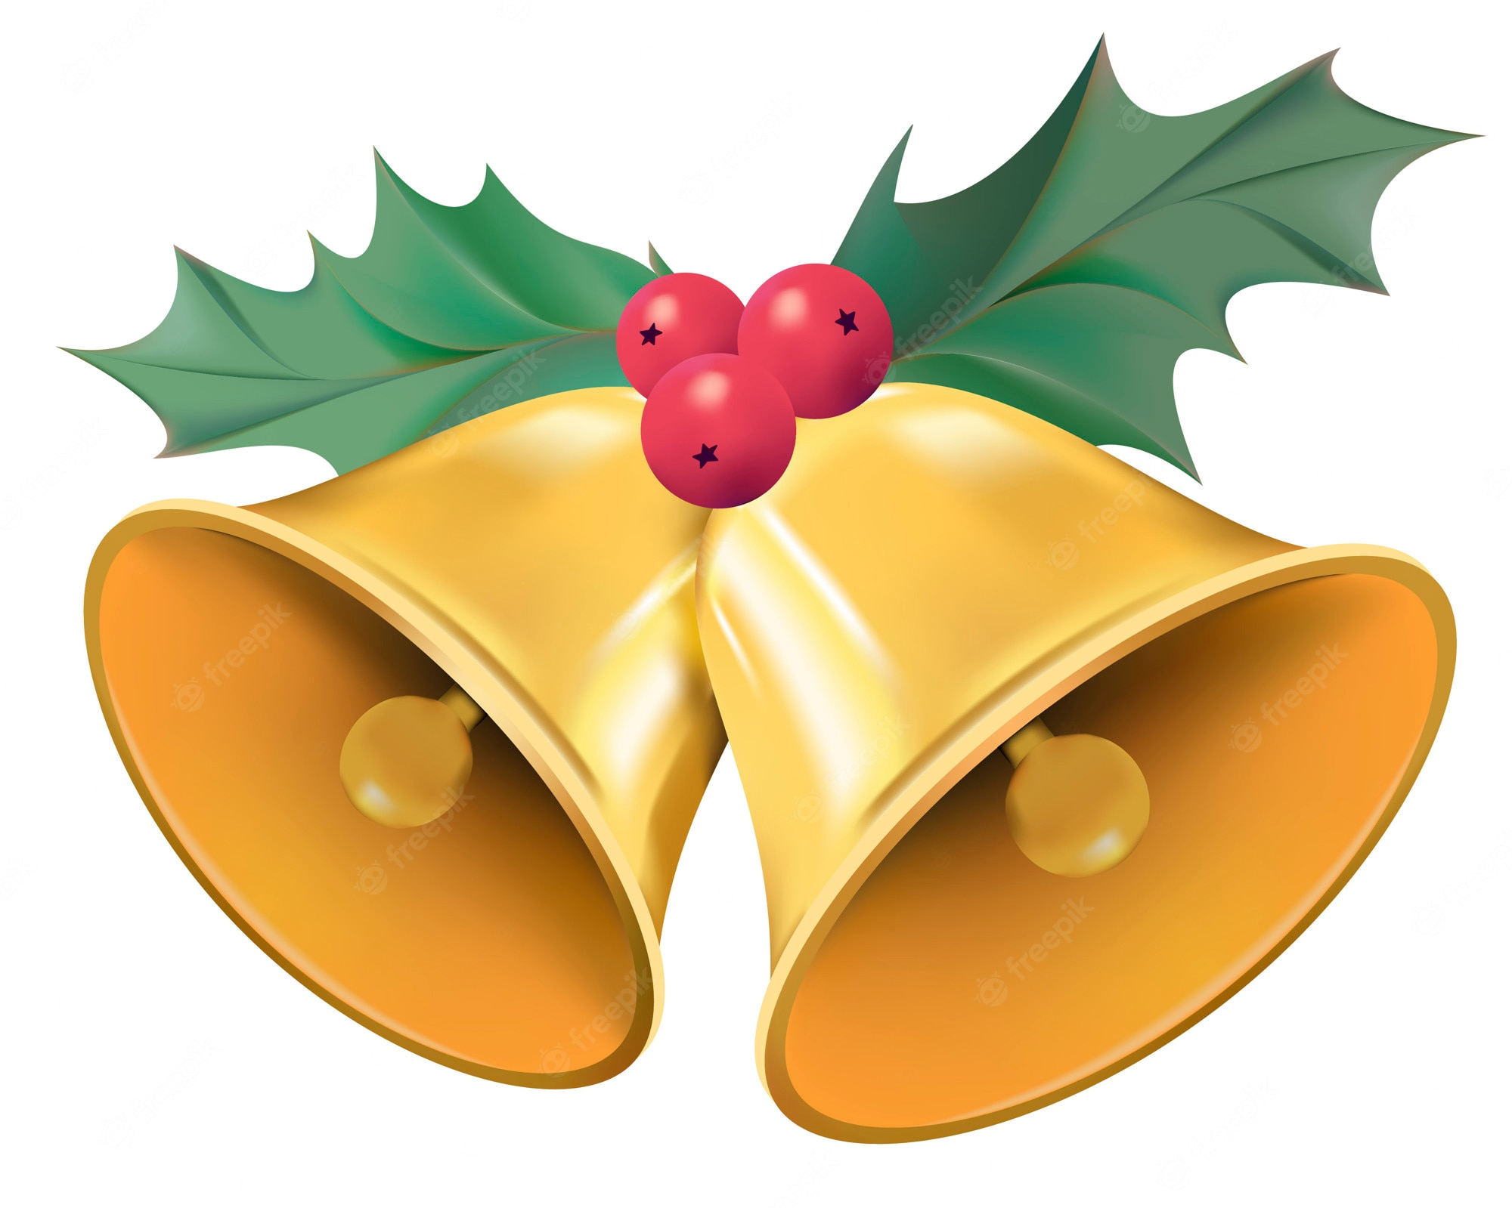
5th December 2022
Christmas at Park

Dear Parents,

The Christmas tree is up in school and everyone at Park is starting to get into the festive spirit! We have lots of exciting things happening in school over the coming weeks. Please find some key dates for your diary below.

Wednesday 7th December | Panto Day!
Thursday 8th December | Save the Children Christmas Jumper Day | Come to school with a festive jumper/top and bring in a donation to the Save the Children charity.
Wednesday 14th December | Christmas Dinner Day
Wednesday 14th December | F1/F2 Christmas Performance
Thursday 15th December | Y1/2 Christmas Performance
Thursday 15th December | Christmas Carol Concert | More information to follow
Monday 19th December | Christmas discos | More information to follow
Tuesday 20th December | Break up for the Christmas holidays

We will return to school on Wednesday 4th January 2023.

